CITY OF ALBANY, NY
BOARD OF CONTRACT AND SUPPLY

Present:
JOEL STETSON, Budget Department
DARIUS SHAHINFAR, Treasurer
ROBERT MAGEE, Corporation Counsel
WILLIAM LECUYER, City Engineering
FRANK ZEOLI, Department of General Services

*Motion to adopt the agenda was made by Frank Zeoli and seconded by Joel Stetson followed by a unanimous vote in the affirmative.

* Motion to adjourn was made by Darius Shahinfar and seconded by Frank Zeoli followed by a unanimous vote in the affirmative.

This meeting will be live streamed to YouTube at: https://www.youtube.com/channel/UCw2w4CdeaI5sd8lQPUDlcyw

The Department of Recreation offers the following:

RESOLVED, that the Secretary be authorized and directed to advertise for bids for the following:

COURT RESURFACING OF CITY PARKS IN 2026

BIDS TO BE RECEIVED

Said proposals to be received by the Board at a regular meeting to be held Tuesday, November 4, 2025 at 1:30 P.M. A bid deposit is not required for this solicitation for bids.

Mr. Lecuyer offered the following:

Resolved, that the Secretary be authorized and directed to advertise for bids for the following:

City of Albany
Maintenance Contract for Plumbing Work
for Various City Owned Buildings
City of Albany, New York

BIDS TO BE RECEIVED

Said proposals to be received by the Board at a regular meeting to be held on Tuesday, October 21, 2025 at 1:30 p.m. and that each bidder be required to present with the bid a deposit in the amount equal to 5% of the total bid in a bid bond or certified check, conditioned upon entering into the contract if the bid is accepted and for the performance of the same.

Mr. Lecuyer offered the following:

Resolved, that the Secretary be authorized and directed to advertise for bids for the following:

City of Albany
Maintenance Contract for Roofing Work
for Various City Owned Buildings
Albany, New York

BIDS TO BE RECEIVED

Said proposals to be received by the Board at a regular meeting to be held on Tuesday, October 21, 2025 at 1:30 p.m. and that each bidder be required to present with the bid a deposit in the amount equal to 5% of the total bid in a bid bond or certified check, conditioned upon entering into the contract if the bid is accepted and for the performance of the same.

Mr. Lecuyer offered the following:

Resolved, that the Secretary be authorized and directed to advertise for bids for the following:

City of Albany
HVAC and Temperature Control
Inspections and Service Contract for
Various City Owned Buildings
City of Albany, New York

BIDS TO BE RECEIVED

Said proposals to be received by the Board at a regular meeting to be held on Tuesday, October 21, 2025 at 1:30 p.m. and that each bidder be required to present with the bid a deposit in the amount equal to 5% of the total bid in a bid bond or certified check, conditioned upon entering into the contract if the bid is accepted and for the performance of the same.

The Albany Water Board offers the following:
RESOLVED, that the Secretary be authorized and directed to advertise for bids for the following:

PURCHASE OF A FORK LIFT FOR ALBANY WATER BOARD
BIDS TO BE RECEIVED

Said proposals to be received by the Board at a regular meeting to be held Tuesday,
November 4, 2025 at 1:30 P.M. A bid deposit is not required for this solicitation for bids

Mr. Zeoli offered the following:

RESOLVED, That the Secretary be authorized and directed to advertise for bids for the following:

Golf Cart Lease

BIDS TO BE RECEIVED

Said proposals to be received by the Board at a regular meeting to be held Tuesday, November 4, 2025 at 1:30 P.M., and that a bid deposit is not required for said bid proposal.

Mr. Zeoli offered the following:
RESOLVED, That the Secretary be authorized and directed to advertise for bids for the following:

Purchase & Installation of Fuel Distribution System
BIDS TO BE RECEIVED

Said proposals to be received by the Board at a regular meeting to be held Tuesday, November 4, 2025 at 1:30 P.M., and that each bidder be required to present with the bid a deposit in the amount equal to 5% of the total bid in a bid bond or certified check, conditioned upon entering into the contract if the bid is accepted and for the performance of the same.
.

Mr. Zeoli offered the following:

RESOLVED, That the Secretary be authorized and directed to advertise for bids for
the following:

Purchase of Tulips and Summer Flowering Bulbs

BIDS TO BE RECEIVED

Said proposals to be received by the Board at a regular meeting to be held Tuesday, November 4, 2025 at 1:30 P.M., and that a bid deposit is not required for said bid proposal.
BOARD OF CONTRACT AND SUPPLY
City of Albany, NY

Date Bids Received: October 10, 2025

Title: Maintenance Contract for Overhead Door Repairs VCOB

Requesting Department: Engineering

Name of Bidder | Security | Amount of Bid
All Types of Doors, Inc.  400 North Pearl Street  Albany, NY 12207 | Bid Bond Required | Base Bid: $ 48,750.00

BOARD OF CONTRACT AND SUPPLY
City of Albany, NY

Date Bids Received: October 10, 2025

Title: Purchase of Road Salt

Requesting Department: General Services

Name of Bidder | Security | Amount of Bid
Apalachee, LLC  1423 Highland Avenue  Rochester, NY 14620 | Bid Bond Not Required | Base Bid: See below
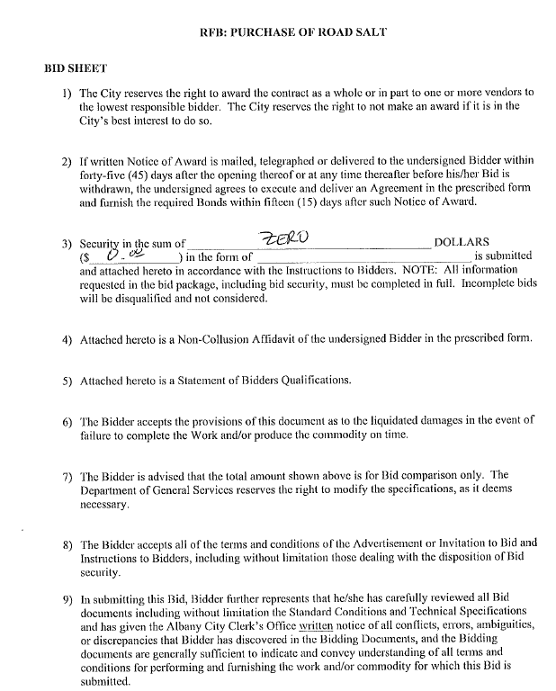
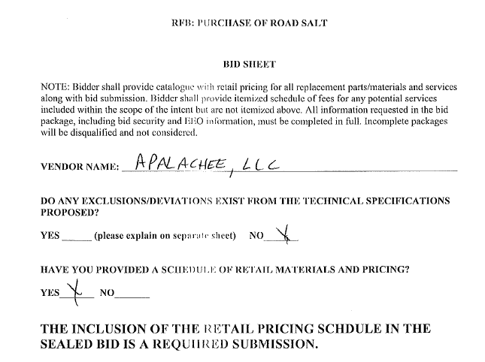
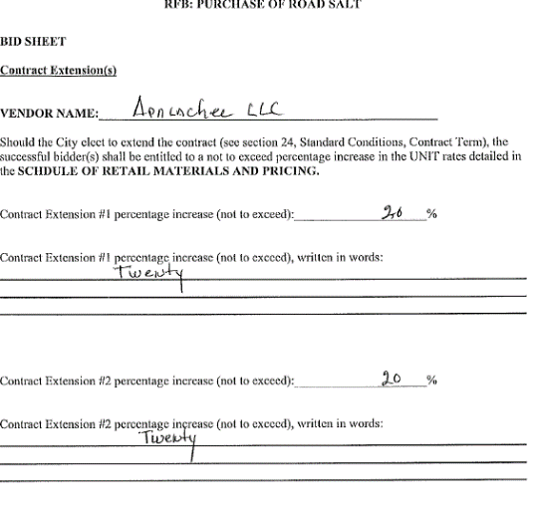
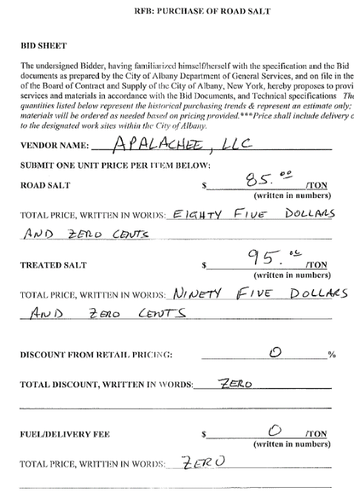
BOARD OF CONTRACT AND SUPPLY
City of Albany, NY

Date Bids Received: October 10, 2025

Title: Light Vehicle Parts, Preventative Maintenance and Repair

Requesting Department: General Services

Name of Bidder | Security | Amount of Bid
Exit 5 Auto  625 Watervliet Shaker Road  Latham, NY 12110 | Bid Bond Not Required | Base Bid: See below
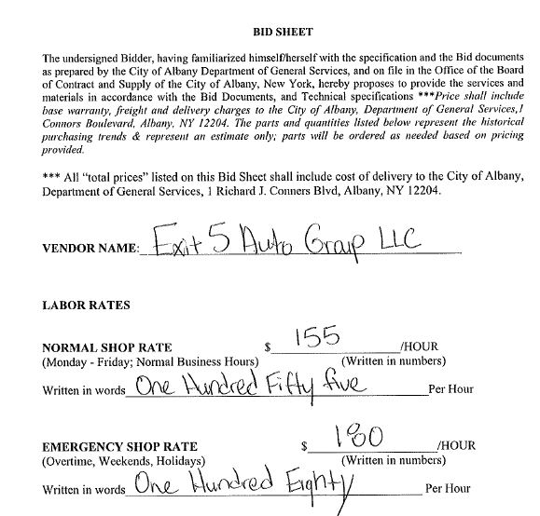
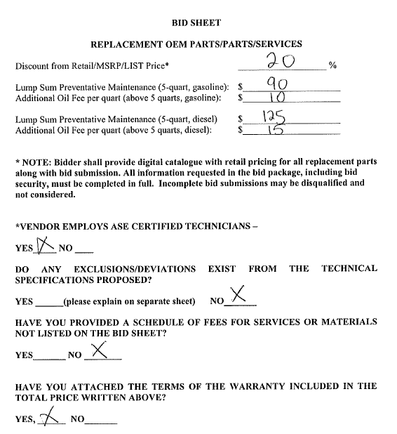
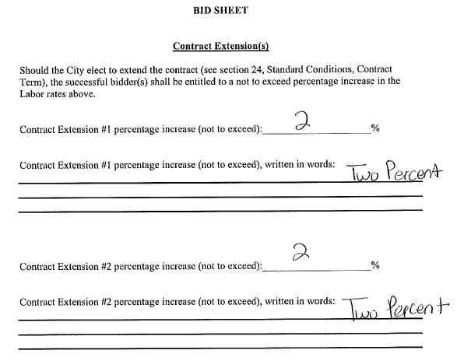
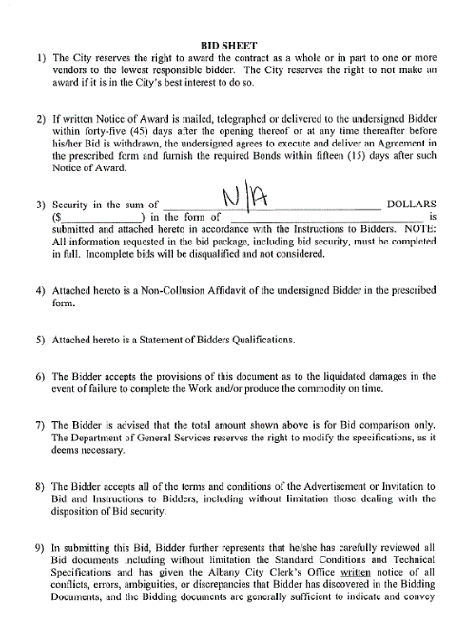
BOARD OF CONTRACT AND SUPPLY
City of Albany, NY

Date Bids Received: October 10, 2025

Title: Shed Installation and Service

Requesting Department: General Services

Name of Bidder | Security | Amount of Bid
Carport Central  Garrett Nelson  1018 Rockford Street  Mt. Airy, NC 27030 | Bid Bond Not Required | Base Bid: See below
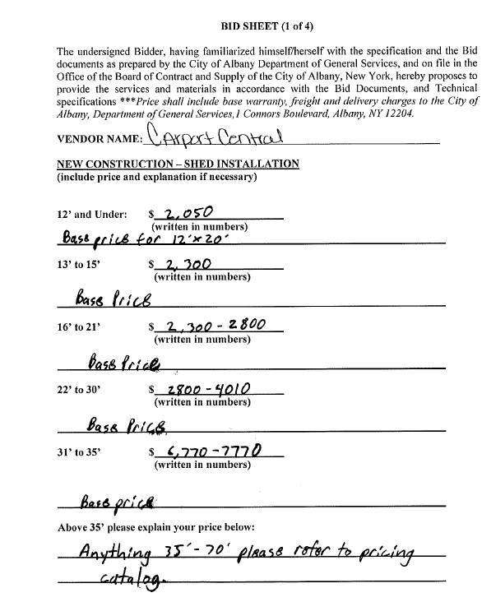
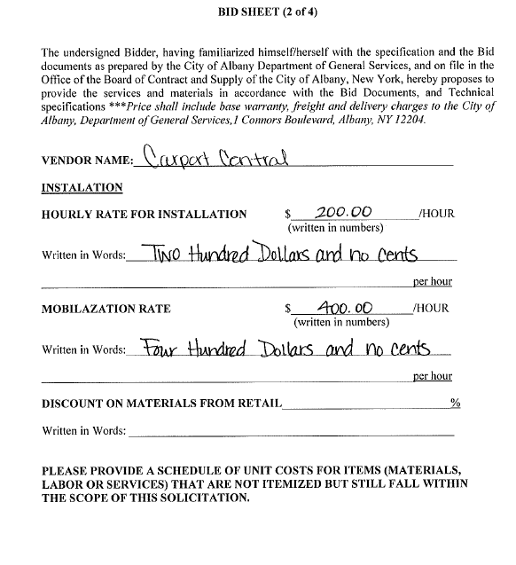

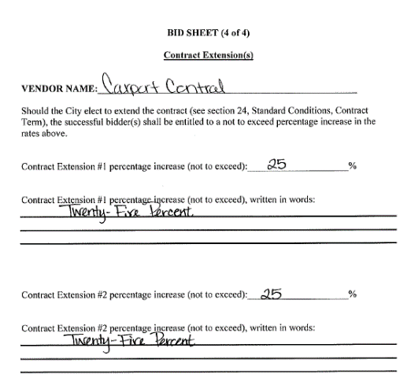
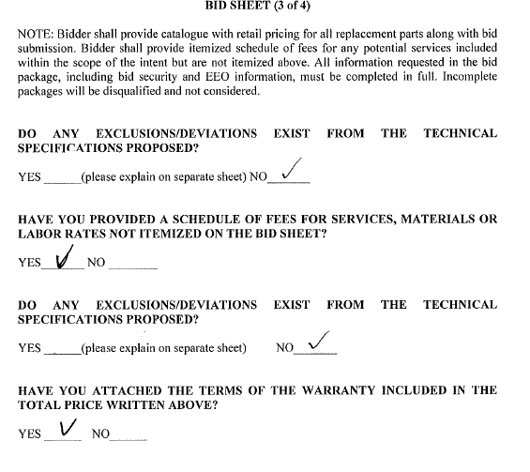
BOARD OF CONTRACT AND SUPPLY
City of Albany, NY

Date Bids Received: October 10, 2025

Title: Building Materials & Associated Products

Requesting Department: General Services

Name of Bidder | Security | Amount of Bid
No Bid Submissions

Mr. Lecuyer offered the following:

Resolved, that the bid of the following named bidder be accepted and the contract awarded to them, at and for the prices specified in their proposal, they being the lowest qualified bidder and theirs being the lowest qualified bid, and that the Mayor be authorized to sign the contract on behalf of the City and affix its seal thereto.

Project: Maintenance Contract for Electrical Work
for Various City Owned Buildings
City of Albany, New York

Bidder: Empire Electric NY, LLC
P. O. Box 13082
Albany, New York 12212

Bid Amount: $37,250.00

Mr. Lecuyer offered the following:

Resolved, that the bid of the following named bidder be accepted and the contract awarded to them, at and for the prices specified in their proposal, they being the lowest qualified bidder and theirs being the lowest qualified bid, and that the Mayor be authorized to sign the contract on behalf of the City and affix its seal thereto.

Project: Maintenance Contract for Pest Control Services
for Various City Owned Buildings
City of Albany, New York

Bidder: Rentokill Terminix
22 Kairnes Road
Albany, NY 12025

Bid Amount: $17,653.00

The following resolution was offered on behalf of the Albany Water Board:

RESOLVED, that the bid for the following named bidder be accepted and the contract awarded to them, at and for the prices specified in their proposal, they being the lowest qualified bidder and theirs being the lowest qualified bid, and that the Mayor be authorized to sign the contract on behalf of the City and affix its seal thereto.

PROJECT: Beaver Creek Clean River Project – Heating Upgrades

BIDDER: Flach Industries, Inc.
1521 US-9W
Selkirk, NY 12158

BID AMOUNT: $129,690.00

DATE OF RECEIPT OF BID: September 16, 2025

Mr. Lecuyer offered the following:

Resolved, that an increase in the amount of $1,298,785.82, Change Order No. 4, be made to the City Hall Roof Replacement Project, Contract 9345. The new contract value will be $11,004,611.89. The new completion date shall be January 16, 2026.

Mr. Lecuyer offered the following:

Resolved, that an increase in the amount of $50,065.59, Change Order No. 2, be made to Contract # 9358 - Brevator Street Reconstruction Project. The new contract value will be $4,810,364.97. The final completion date has been revised to November 1, 2025.

Mr. Daley offered the following:

Resolved, that a decrease in the amount of $35,000.00, Change Order No. 1, be made to BPI Plumbing (Contact #9394, Albany West Recreation Center). These funds are to be removed from the allowance line. The new contract value will be $614,500.00. No change is proposed for the final completion date.

Mr. Daley offered the following:

Resolved, that a decrease in the amount of $45,000.00. Change Order No. 1, be made to DiGesare Mechanical (Contact #9393, Albany West Recreation Center). These funds are to be removed from the allowance line. The new contract value will be $869,000.00. No change is proposed for the final completion date.

Mr. Daley offered the following:

Resolved, that increase in the amount of $48,949.00. Change Order No. 2, be made to Caruso (Contact #9391, Albany West Recreation Center). This change order is required for field condition changes required by the Department of Health (surge tanks), National Grid (transformer pad) and soil conditions (testing and removal). The new contract value will be $1,005,549.14. No change is proposed for the final completion date.

Mr. Daley offered the following:

Resolved, that an increase in the amount of $85,024.00 Change Order No. 3, be made to AOW (Contact #9392, Albany West Recreation Center). This change order is required for field condition changes required National Grid (transformer pad) and low voltage wiring (security and cameras). The new contract value will be $13,915,104.00. No change is proposed for the final completion date.

Mr. Daley offered the following:

Resolved, that an increase in the amount of $29,502.21. Change Order No. 1, be made to Kompan Purchase Agreement SP158055-1 (Washington Park Playground). This change order is required for prevailing wage rate adjustment and the installation of an additional accessible swing. The new contract value will be $758,882.61. No change is proposed for the final completion date.

