CITY OF ALBANY, NY
BOARD OF CONTRACT AND SUPPLY

Present:
JOEL STETSON, Budget Department
DARIUS SHAHINFAR, Treasurer
ROBERT MAGEE, Corporation Counsel
WILLIAM LECUYER, City Engineering
FRANK ZEOLI, Department of General Services

*Motion to adopt the agenda was made by Frank Zeoli and seconded by Darius Shahinfar followed by a unanimous vote in the affirmative.

* Motion to adjourn was made by Darius Shahinfar and seconded by Frank Zeoli followed by a unanimous vote in the affirmative.

This meeting will be live streamed to YouTube at: https://www.youtube.com/channel/UCw2w4CdeaI5sd8lQPUDlcyw

Mr. Lecuyer offered the following:

Resolved, that the Secretary be authorized and directed to advertise for bids for the following:

Maintenance Contract for Emergency Generators
for Various City Owned Buildings
City of Albany, New York

BIDS TO BE RECEIVED

Said proposals to be received by the Board at a regular meeting to be held Friday, September 5, 2025 at 1:30 p.m., and that each bidder be required to present with the bid a deposit equal in amount to 5% of the total bid in a bid bond or certified check, conditioned upon his entering into the contract if his bid be accepted and for the performance of the same.
The following was offered on behalf of the Albany Water Board:

RESOLVED, that the Secretary be authorized and directed to advertise for bids on behalf of the Albany Water Board for the following:

Beaver Creek Clean River Project – Heating Upgrades (HVAC)

BIDS TO BE RECEIVED

Said proposals to be received by the Board at a regular meeting to be held Tuesday, September 16, 2025 at 1:30 P.M., and that each bidder be required to present with the bid a deposit equal in amount to 5% of the total bid in a bid bond or certified check, conditioned upon his entering into the contract if this bid be accepted and for the performance of the same.
Ms. Crerand offered the following:

Resolved, that the bid of the following named bidder be accepted and the contract awarded to them, at and for the prices specified in their proposal, they being the lowest qualified bidder and theirs being the lowest qualified bid, and that the Mayor be authorized to sign the contract on behalf of the City and affix its seal thereto.

PROJECT: Citywide Promotional and Clothing Merchandise & Associated Embroidery Services

BIDDER: JC Smith, Inc.

BID AMOUNT: See bid sheet
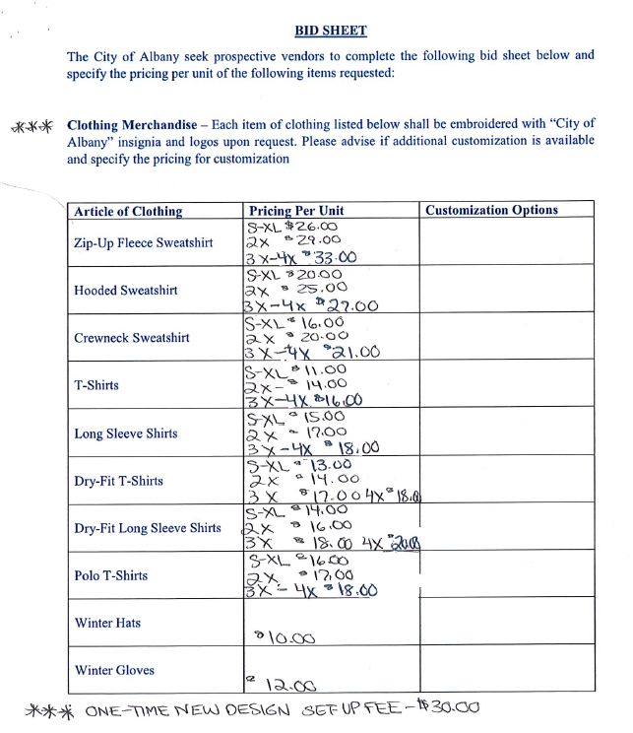

Poulomi Sen from the Planning Department offered the following:

Resolved, that in accordance with the existing contract provisions of City Contract No. 9406 that the following named contract be extended until December 1, 2025 at and for the prices and terms specified in the existing contract.

Project Title: Tivoli Preserve Enhancement

Bidder: CFI Contracting, Inc.
286 Sacandaga Road
Johnstown, NY 12095

Amount: $2,193,900.00

