CITY OF ALBANY, NY
BOARD OF CONTRACT AND SUPPLY

Present:
GIDEON GRANDE, Budget Department
NICK RILEY, Treasurer
ROBERT MAGEE, Corporation Counsel
WILLIAM LECUYER, City Engineering

*Motion to adopt the agenda was made by Gideon Grande and seconded by Robert Magee followed by a unanimous vote in the affirmative.

* Motion to adjourn was made by Gideon Grande and seconded by Robert Magee followed by a unanimous vote in the affirmative.

This meeting will be live streamed to YouTube at: https://www.youtube.com/channel/UCw2w4CdeaI5sd8lQPUDlcyw

BOARD OF CONTRACT AND SUPPLY
City of Albany, NY

Date Bids Received: August 5, 2025

Title: Purchase of City Promotional & Clothing Merchandise

& Associated Embroidery Services

Requesting Department: Purchasing

Name of Bidder | Security | Amount of Bid
JC Smith, Inc.  345 Peat Street  Syracuse, NY 13210 | Bid Bond Not Required | See below
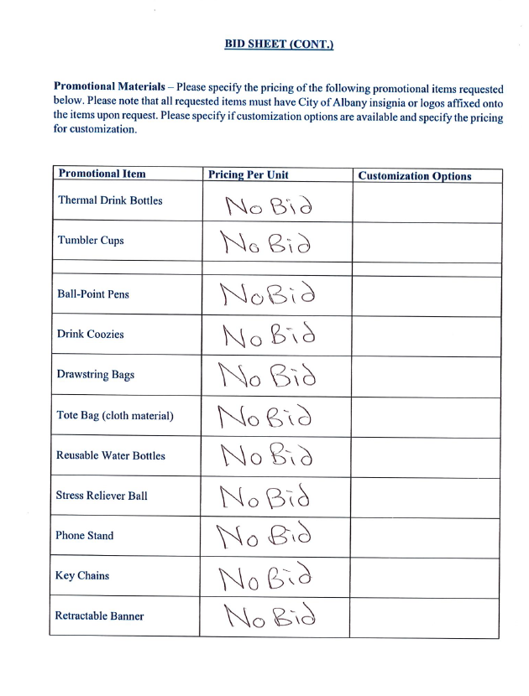
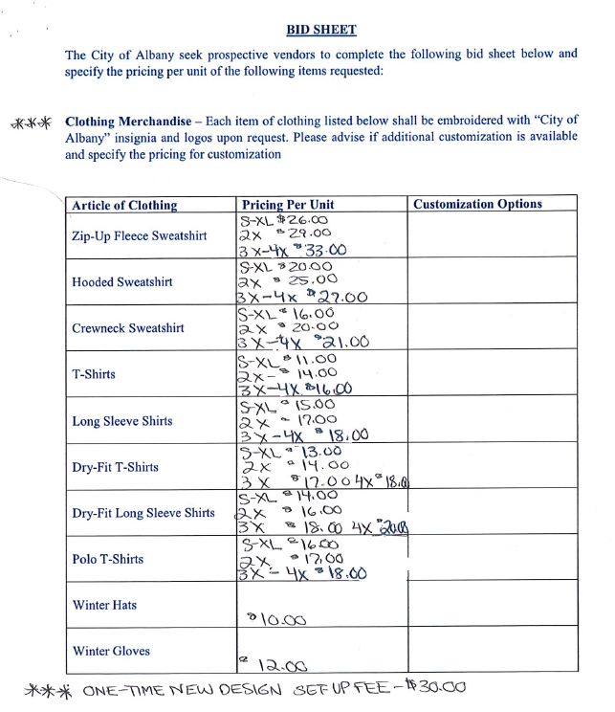
Mr. Lecuyer offered the following:

Resolved, that a decrease in the amount of $24,055.00, Change Order No. 2, be made to Contract No. 9407 – Tricentennial Park Reconstruction Project. The new contract value will be $1,138,237.00. There is no change in contract times.

Mr. Lecuyer offered the following:

Resolved, that an increase in the amount of $328,133.86, Change Order No. 3, be made to the City Hall Roof Replacement Project, Contract 9345. The new contract value will be $9,641,953.68. There is no change in contract times.

Mr. Daley offered the following:

Resolved, that an increase in the amount of $7,885.70, Change Order No. 1, be made to Jersen Construction Group’s Contract 9396 for the Lincoln Park Pool Water Line (“Contract #4”). This cost is for temporary sidewalk on Park Ave requested by NYSOGS. The new contract value will be $682,760.70. There is no change in contract times.

The following resolution was offered on behalf of the Albany Water Board:

RESOLVED, that in accordance with the existing contract provisions of City Contract No. 9386, the Albany Water Board approves Change Order LM-G-03 to the following named contract with the following named contractor. The contract completion date remains January 17, 2026.
PROJECT TITLE: Feura Bush WFP – Lime and Maintenance Building - General
CONTRACTOR: AMZ Construction Services, Inc.
1234 Main Street
PO Box 232
Rotterdam Junction, NY 12150

AMOUNT OF INCREASE: $13,231.14
AMOUNT OF NEW CONTRACT: $1,192,612.55

Mr. Daley offered the following:

Resolved, that, Change Order No. 1, be made to Surpass Chemical’s Contract for the Lincoln Park Pool Chemical Supply. Change Order allows the City to purchase liquid chlorine as a substitute and shock to supplement to the Chlorine Tables identified in the contract. There is no change in contract times or value.

