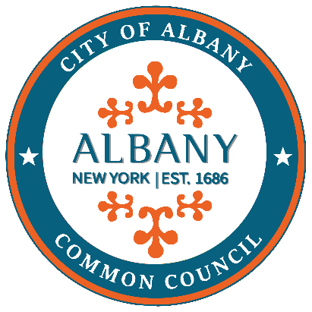
VIOLENCE PREVENTION TASK FORCE
VIOLENCE PREVENTION TASK FORCE COORDINATOR – Eric Thompson

DATE: TUESDAY, AUGUST 5th, 2025

TIME: 5:45PM

LOCATION: Council Chambers-2nd Floor, City Hall

LIVESTREAM: YouTube— https://www.youtube.com/@albanycommoncouncil

Facebook— https://www.facebook.com/albany.commoncouncil

TOPICS OF DISCUSSION:

- Vote on report
- Discuss dates and locations for community events

PUBLIC COMMENT PERIOD: YES

