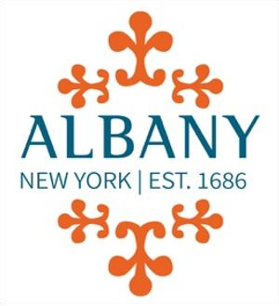

PUBLIC, EDUCATION AND GOVERNMENT ACCESS OVERSIGHT BOARD
(PEGAOB)
City of Albany
City Hall
24 Eagle Street, Albany NY

MEETING NOTICE & AGENDA

Date: March 19, 2026
Time: 5:30 PM
Location: Mayor's Conference Room, City Hall

ORDER OF BUSINESS
Call to Order
Roll Call
Approval of Minutes – February 19, 2026
Public Comment
Treasurer's Report
Chair’s Report
Studio Coordinator's Report
Unfinished Business
New Business
Miscellaneous Business and Announcements
Adjournment

